

**Stockport**

**Neighbourhood Watch**

FRONT BACK

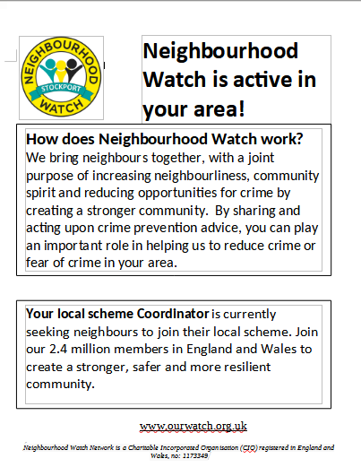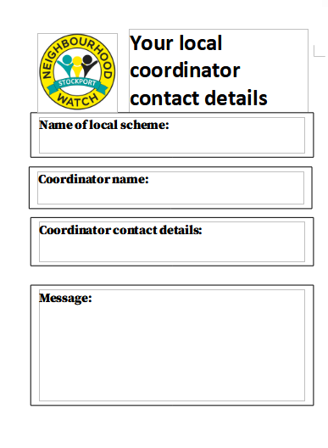

You should have some of these introductory cards in your coordinator pack.

You can print off more from the link below, fill in your contact detail and message (perhaps inviting to a meeting) on all 4 locations before printing off. 4 cards per A4 sheet. Print off double sided flipping on long side if your printer has double sided option, if not put through printer twice.

Control click this [LINK](https://www.stockportnwa.org/coordinatorResources/fbe5818a-27a7-4013-8eb6-873e430b36f9CallingCard.docx) for the print file in Word (editable with your details)

Control click this [LINK](https://www.stockportnwa.org/coordinatorResources/09922025-d282-49f0-b42b-7656c2ced0c4callingcardx4rtf.rtf) for the print file in rtf format (editable)

Control click this [LINK](https://www.stockportnwa.org/coordinatorResources/b5633d0d-7763-45da-8642-b8a4dd6feb4ecallingcardx4pdf.pdf) for the print file in pdf format (not editable).